Yunlu Li

CS 4780

MP2

**Question 1**

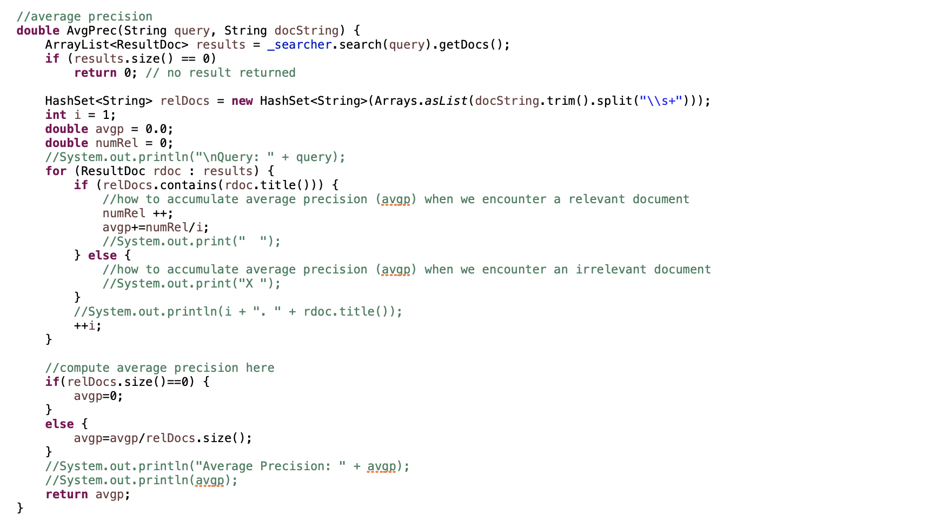

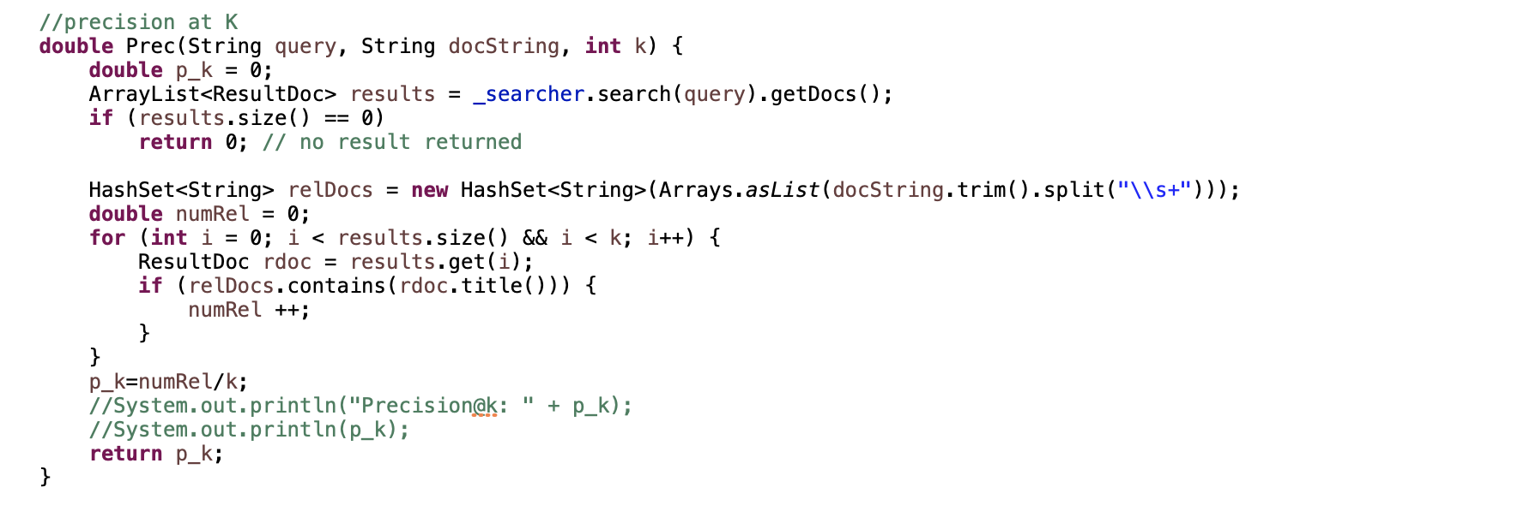

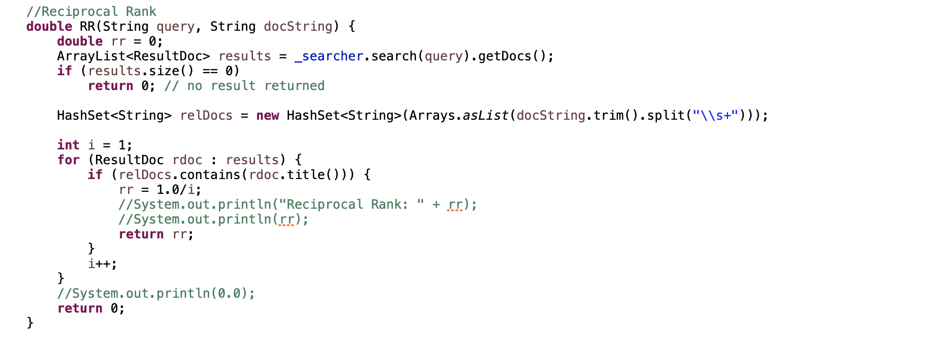

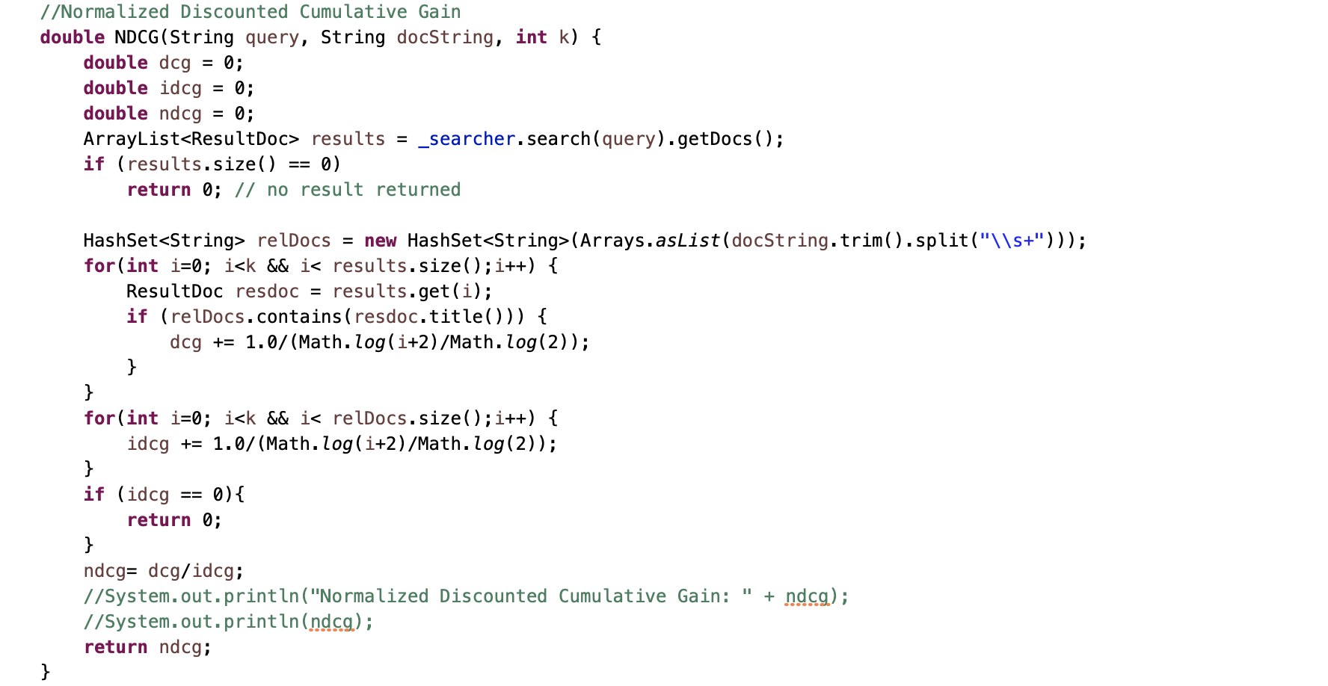

The final MAP/P@10/MRR/NDCG@10 performance from each ranking function:

|  |  |  |
| --- | --- | --- |
|  | BM25 | Dot Product |
| MAP | 0.27524149426286965 | 0.28405788399801385 |
| P@10 | 0.34623655913978496 | 0.35053763440860214 |
| MRR | 0.674808203578191 | 0.6905643241833787 |
| NDCG@10 | 0.42603032215453884 | 0.4312359204708965 |

Note: the *defaultNumResults* are 1000.

**Question 2**

First, I only removed the lower-case filter or length filter. The result is shown in the table below. As we can see, there is almost no effect on the effectiveness after removing the filters. I realized that this retrieval is about academic paper, so titles are already standardized. This means the lower-case or length filter does not have much effect under such circumstances.

(Note: the *defaultNumResults* are 1000).

|  |  |  |  |
| --- | --- | --- | --- |
|  | Original BM25 | BM25 without Lower-case Filter | BM25 without Length Filter |
| MAP | 0.27524149426286965 | 0.27524149426286965 | 0.2773372647192524 |
| P@10 | 0.34623655913978496 | 0.34623655913978496 | 0.3483870967741936 |
| MRR | 0.674808203578191 | 0.674808203578191 | 0.6880613997715862 |
| NDCG@10 | 0.42603032215453884 | 0.42603032215453884 | 0.4300451674422876 |

Then, I tested the effect of document analyzer on retrieval effectiveness by disabling stopword removal. Overall, lack of stopword removal makes retrieval less effective because all four metrics decrease, but the drop is very small. To further test the conclusion, I disabled stopword removal and stem. As we can see from the table below, all metrics showed a great drop. As we know, the BM25 uses bag-of-word as foundation, so lack of stemming makes it hard to transform words into original forms and thus BM25 becomes less effective. Therefore, we conclude that the filter pipeline built in the document analyzer makes the retrieval effective. Without those filters, the retrieval becomes less effective.

(Note: the *defaultNumResults* are 1000).

|  |  |  |  |
| --- | --- | --- | --- |
|  | Original BM25 | BM25 without Stopword Removal | BM25 without Stopword Removal and Stem |
| MAP | 0.27524149426286965 | 0.27133160186921407 | 0.20617530855162403 |
| P@10 | 0.34623655913978496 | 0.3344086021505377 | 0.2752688172043011 |
| MRR | 0.674808203578191 | 0.6739268398734564 | 0.6487186601847095 |
| NDCG@10 | 0.42603032215453884 | 0.4129613899798967 | 0.3501253435060279 |

**Question 3**

One-tail p-value:

|  |  |  |  |  |
| --- | --- | --- | --- | --- |
|  | MAP | P@10 | MRR | NDCG@10 |
| Paired t-test | 0.032627082 | 0.294474856 | 0.160087207 | 0.246149344 |
| [Wilcoxon signed-rank test](https://en.wikipedia.org/wiki/Wilcoxon_signed-rank_test) | 0.0116 | 0.31918 | 0.22363 | 0.32636 |

Two-tail p-value:

|  |  |  |  |  |
| --- | --- | --- | --- | --- |
|  | MAP | P@10 | MRR | NDCG@10 |
| Paired t-test | 0.065254165 | 0.588949712 | 0.320174413 | 0.492298688 |
| [Wilcoxon signed-rank test](https://en.wikipedia.org/wiki/Wilcoxon_signed-rank_test) | 0.0232 | 0.63836 | 0.44726 | 0.65272 |

From the table above, except MAP, we can see that all two-tail p-values are bigger than the significance level 0.05, which suggests that we cannot reject the null hypothesis. This means that the observed difference in P@10, MRR and NDCG@10 is insignificant, so we cannot determine which ranking algorithm is better for those matrices.

For MAP, the two-tail p-value of paired t-test is bigger than 0.05 whereas [Wilcoxon signed-rank test](https://en.wikipedia.org/wiki/Wilcoxon_signed-rank_test) has two-tail p-value less than 0.05. Then let us take a closer look at one-tail p-value. The one-tail p-value from both paired t-test and Wilcoxon signed-rank test are less than 0.05. This means we reject the null hypothesis. Dot Product is better than BM25 under MAP in both paired t-test and Wilcoxon signed-rank test.